**Neha Malhotra**  **R.L. Institute M: 9253556635**

**Max Time : 1 ½ hr** **Class = 12th Biology Test Max Marks : 45**

**Topic: Unit – 4 (Biotechnology)**

**Section – A [ 1 X 10 = 10 ]**

1. Use of bioresources by multinational companies and other organisations without proper authorization from the countries and people concerned and without compensatory payment is termed as:

|  |  |  |  |
| --- | --- | --- | --- |
| a) resource partitioning | b) Biopiracy | c) Patenting | d) Biofortification. |

1. What is the criterion for DNA fragments movement on Agarose gel during gel electrophoresis?
2. The smaller the fragment size, the farther it moves.
3. Positive charged the fragments move to farther ends.
4. Negative charged the fragments do not move.
5. The Larger the fragment size, the farther it moves.
6. Select the correct match

Gene Target insects

A. Cry I Ac (i) Cotton bollworm

B. Cry II Ab (ii) Corn Borer

C. Cry I Ab (iii) Cotton bollworm

|  |  |  |  |
| --- | --- | --- | --- |
| a) A only | b) A and C only | c) B and C only | d) A , B and C. |

1. Micropropagation involves:
2. Vegetative multiplication of plants by using microorganisms.
3. Vegetative multiplication of plants by using small explants.
4. Vegetative multiplication of plants by using microspores.
5. Non- Vegetative multiplication of plants by using microspores and megaspores.
6. Study the following figures and identify the enzymes involved in step I and step II respectively.

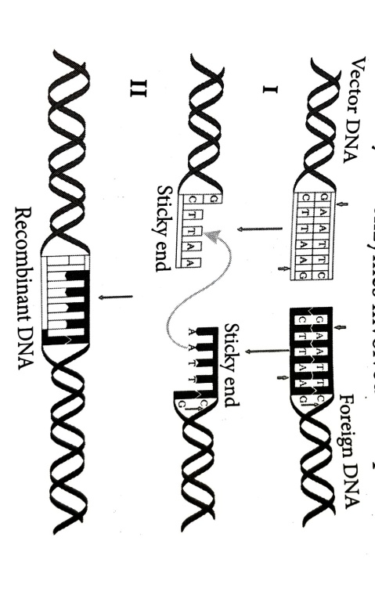

|  |  |
| --- | --- |
| a) I = EcoR I and II = DNA ligase | b) I = Hind II and II = DNA ligase |
| c) I = EcoR I and II = Hind II | d) Restriction endonuclease and exonuclease |

1. Which of the following statements is correct?
2. The first restriction endonuclease was EcoRI.
3. Plasmid pBR322 has 2 selectable marker i.e. AmpR and tetR.
4. Electrophoresis is a technique of separation of DNA molecule on the basis of their density.
5. Topoisomerases are called molecular scissors.

**Assertion-Reason Type Questions**

**DIRECTIONS :** In each of the following questions, a statement of Assertion (A) is given followed by a corresponding statement of Reason (R) just below it. Of the statements, mark the correct answer as:

1. If both assertion and reason are true, but reason is the true explanation of the assertion.
2. If both assertion and reason are true, but reason is not the true explanation of the assertion.
3. If assertion is true, but reason is false.
4. If both assertion and reason are false.
5. **Assertion:** Selectable marker is meant for distinguishing a recombinant and non-recombinants.

**Reason:** Non-recombinant cannot flourish in medium having both ampicillin and tetracycline, antibiotic resistance gene.

1. **Assertion:** GM plants are made tolerance to abiotic stress.

**Reason:** Golden rice is rich in B-carotene.

1. **Assertion:** Agrobacterium tumefaciens is the causative agent of crown gall disease of dicots.

**Reason:** Agrobacterium tumefaciens transforms normal cell into tumors by inserting T-DNA.

1. **Assertion:** Restriction enzymes cut the strand of DNA to produce sticky ends.

**Reason:** Stickiness of the ends facilitates the action of the enzyme DNA polymerase.

**Section – B [ 2 X 5 = 10 ]**

1. Why is Taq Polymerase preferred in PCR? Mention the source of this enzyme.
2. What could be the possible treatment for a patient exhibiting ADA deficiency?
3. Read the following base sequence of certain DNA:

5'— CTT AAG —3'

3'— GAA TTC —5'

(a) What are such sequences called? Mention the name of the enzyme that recognizes such nucleotide sequences.

(b) State the significance of the enzyme that identifies these nucleotide sequences.

1. (a) Non-viral and non-vector methods are sometimes used to transfer genes into plant cells. Explain one such method.

(b) Write the name of the restriction enzyme, i.e., EcoRI.

1. How is insertional inactivation of an enzyme used as a selectable marker to differentiate recombinants from non-recombinants?

**Section – C [ 3 X 5 = 15 ]**

1. (a) Why are transgenic animals so called?

(b) Explain the role of transgenic animals in: (i) Vaccine safety (ii) Biological products

(Explain with the help of examples.)

1. (a) Explain the role of Ti plasmid in biotechnology.

(b) Describe the different steps in one complete cycle of PCR. State the purpose of such amplified DNA sequences.

1. (a) Name the insect that attacks cotton crops and causes a lot of damage to the crop. How has Bt cotton solved this problem and saved the crop? Explain.

(b) Write the role of gene cry1Ab.

(c) Write a note on cloning sites.

1. Carefully observe the given picture: A mixture of DNA fragments ranging from 200 bp to 2500 bp was electrophoresed on agarose gel with the following arrangements.

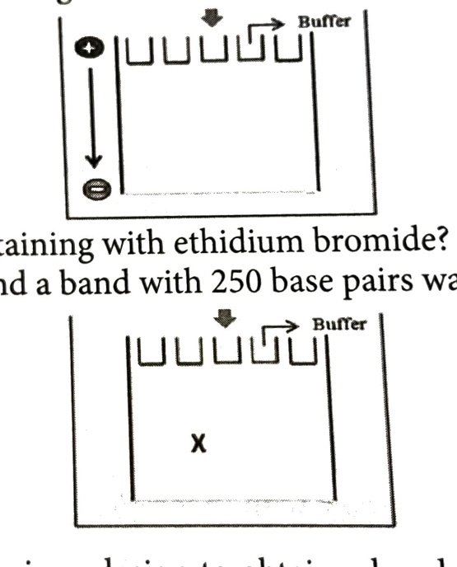

(a) What result will be obtained on staining with EtBr? Explain with reason.

(b) The above setup was modified, and a band with 250 bp was obtained at position X. What changes were made to the previous design to obtain a band with X? Why did the band appear at position X?



1. (a) Plasmid is a boon to biotechnology. Justify this statement, quoting the production of human insulin as an example.

(b) Name the Indian crop variety for which, in 1997, an American company got patent rights through the US Patent and Trademark Office. Why did the company claim it to be an invention or a novelty?

(c) Write the properties/characteristics of plasmids and bacteriophages that make them efficient cloning vectors.

**Section – D [ 5 X 2 = 10 ]**

1. Refer to the diagram of maturation of proinsulin into insulin to answer the following questions.

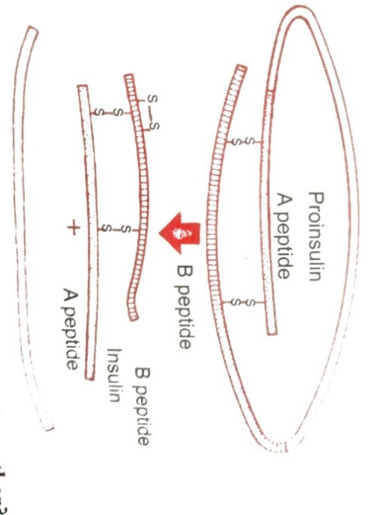

(i) How are two short polypeptide chain of insulin linked together?

(ii) State the role of C-peptide in human insulin.

(iii) Mention the chemical change that proinsulin undergoes, to be able to act as mature insulin.

(iv) Mention the role of Mature insulin in human body.

1. Read the passage and answer the following questions:

Some restriction enzymes breaks a phosphodiester bond on both the DNA strands, such that only one end of each molecule is cut and these ends have a regions of single stranded DNA. BamH1 is one such restriction enzyme which binds at the recognition sequence 5’-GGATCC-3’ and claves

1. What is the objective of this action?
2. Explain how the gene of interest is introduced into a vector.
3. You are given the DNA shown below :

5’ ATTTTGAGGATCCGTAATGTCCT 3’

3’ TAAAACTCCTAGGCATTACAGGA 5’

1. If the DNA was cut with Bam H1, how many DNA fragments would you expect? Write the sequence of these double stranded DNA fragments with their respective polarity.
2. If a gene M was introduced into E.coli cloning vector pBR322 at BamH1 site. What will be its impact on the recombinant plasmids> Give a possible way by which you could differentiate non-recombinant to recombinant plasmids